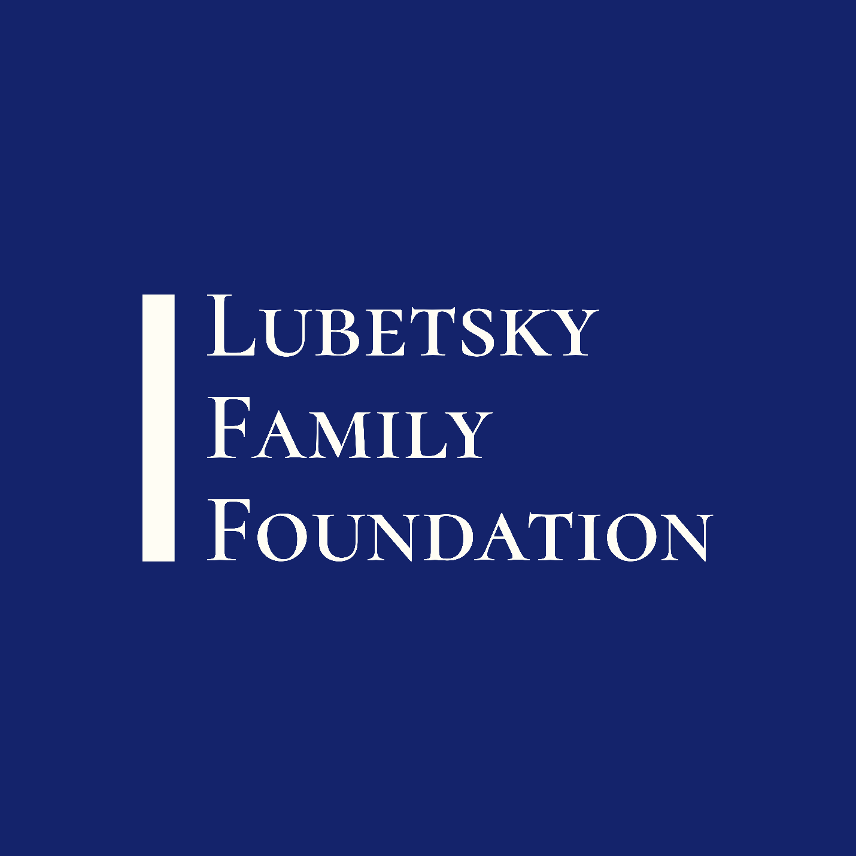

**EDUCATION AND CAREER READINESS PROGRAM**

2021.v.2

# Program Overview

The Lubetsky Family Foundation’s Education and Career Readiness Program supports educational and career readiness projects designed to create opportunity for underserved and marginalized communities.

|  |  |
| --- | --- |
| Published | 15 February 2021 |
| Key Dates | Application Opens: 15 February 2021  Application Closes: 30 October 2020  Merit Review: Rolling, within 90 days of application submission  Awards Announced: Rolling, within 120 days of application submission  Earliest Project Start Date: 01 May 2021  Latest Project Start Date: 01 December 2020 |
| Project Period | One year  Requests for different project period durations will not be reviewed. |
| Budget | Maximum Budget: $25,000  Requests outside the maximum budget parameter will not be reviewed. Funds will be disbursed in two tranches: 50% at the start of the grant period, and 50% upon receipt of a satisfactory mid-year grant report. Unspent grant funds must be returned within 45 days of the close of the grant period. |
| Allowable Expenses | Organizations are encouraged to budget for the personnel who will run their proposed project. Grant funds may be spent on personnel expenses, including fringe benefits; local ground transportation; project-related supplies and capital equipment; other project-related direct expenses; and indirect costs up to 20% of direct expenses. Unallowable expenses include subgrants, airfare; alcoholic beverages and non-programmatic food costs. |
| Eligibility | Applications may be submitted by nonprofit organizations that are tax-exempt under section 501(c)(3) of the Internal Revenue Code. |
| Other Guidelines | Proposed project may not duplicate existing, already funded services. A project director must be named at the time of application. Documentation of 501(c)3 status with the Internal Revenue Service must be included with application. Please save completed narrative application as a PDF for submission and save budget as a separate Microsoft Excel file. Applications may be submitted by e-mail to sara@lubetskyfamilyfoundation.org. |
| Reporting | A programmatic and financial report will be due every six months, 30 days from the close of the reporting period. Templates for programmatic and financial reports will be provided to grantees. |
| Contact | Please contact Sara Lubetsky (sara@lubetskyfamilyfoundation.org) for questions about this application. |

# Application Instructions

|  |  |
| --- | --- |
| Application Title |  |
| Project Director |  |
| Project Director Phone |  |
| Project Director E-mail |  |
| Project Contact (if different from Project Director) |  |
| Project Contact Phone |  |
| Project Contact E-mail |  |
| Applicant Organization |  |
| Applicant Organization Mailing Address |  |
| Project Start Date |  |
| Project End Date |  |
| Total Budget Requested |  |
| One-Sentence Project Overview |  |
| Tell us about your organization, including its mission. (250 words maximum) | |
|  | |
| Describe your proposed project, how it supports education and/or career readiness, and any population(s) of focus your program will serve. (750 words maximum) | |
|  | |
| How will you measure your success? Describe your plan for monitoring and evaluation of the project. This plan should include specific goals, including one for the number of people served (500 words maximum). | |
|  | |
| Who are the key people who will help your project achieve success? Please provide a brief biography for each key person on your budget, as well as their role and responsibilities on the project. Please note, you do not need to tell us about every person receiving salary support under this grant, only the people who are specifically and uniquely qualified to lead it (250 words maximum per person for at least one person). | |
|  | |
| How will you ensure that grant funds are effectively managed, spent according to allowability rules of this request for applications, and not comingled with funds from other sources? (250 words maximum) | |
|  | |
| The following documents must be appended to this application:   * Completed Lubetsky Family Foundation budget template (.xlsx or .xls format) * Documentation of 501(c)3 status with the Internal Revenue Service * Most recent IRS 990 form * Most recent audited financial statement * Documentation of fringe benefit and indirect cost rate policy (if these costs are requested)   If available, submission of the organization’s strategic plan is encouraged, but not required. | |